**Import and connect to database**

**Note: [important]**. You **MUST** have username and password of SQL Service to import and work with database. My username and password are “root”. I don’t know what is yours. Because in real world, there is rare companies use SQlite database for software project, so I try to avoid using it. For game development, SQlite is perfect but for software project, it is not a good solution because there is no secure. Therefore, try to find solution to setup SQL Service to get username and password if you don’t have. If you don’t have, you cannot go next. *In some cases, the default username is “root” and password is blank.*

**Part 1** *Test username and password if password is blank in case you don’t know your password. If you know what it is, skip part 1.*

Step 1: go to services tab, right click on “MySQL Server at localhost….” Then select Properties…

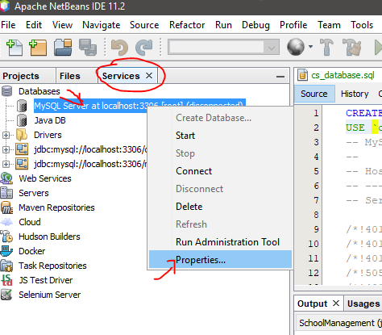

Step 2. New window popup, set Administrator Password is blank. Then click OK

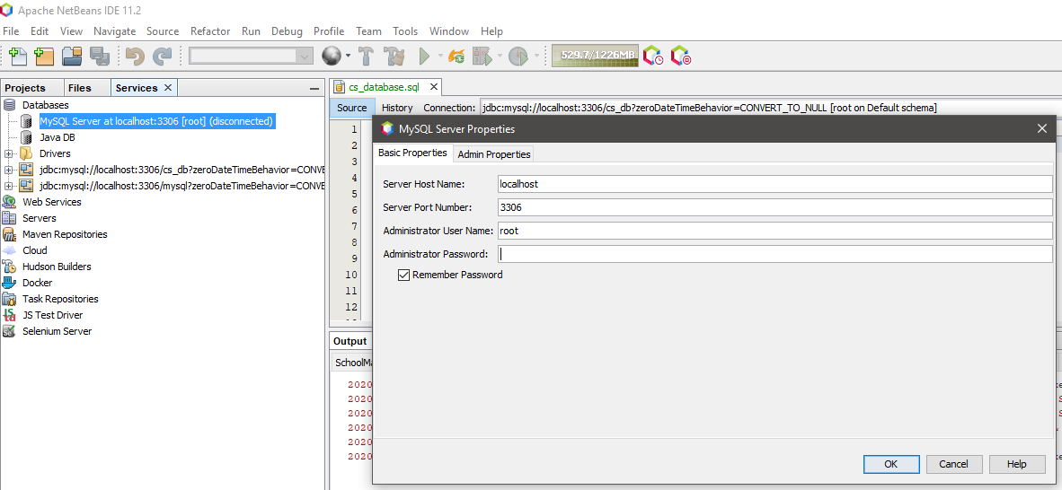

Step 3. Right click on“MySQL Server at localhost…” again then click Start.

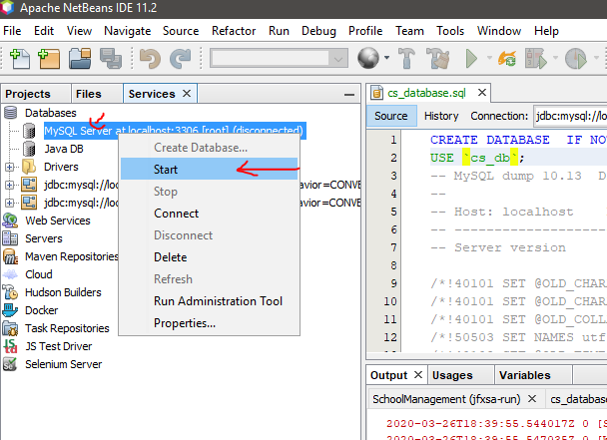

If you see this window popup again with a note “Access denied…” then password is wrong.

If you that window does not popup, then everything is perfect. Go to part 2.

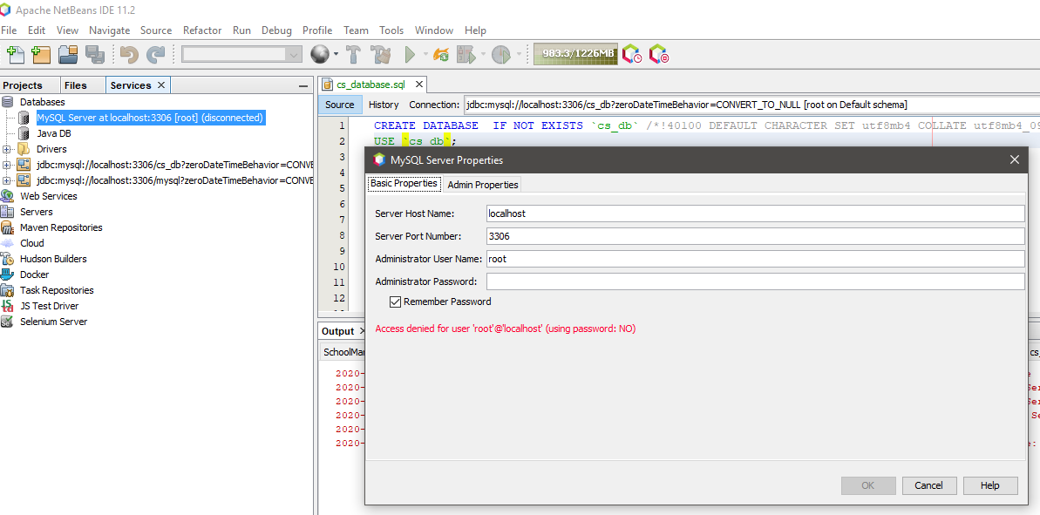

**Part 2**

**Step 1**. Open my project in NetBeans.

**Step 2.** Open **folder** SchoolManagement\src\database\.

**Step 3**. Go to **service** tap.

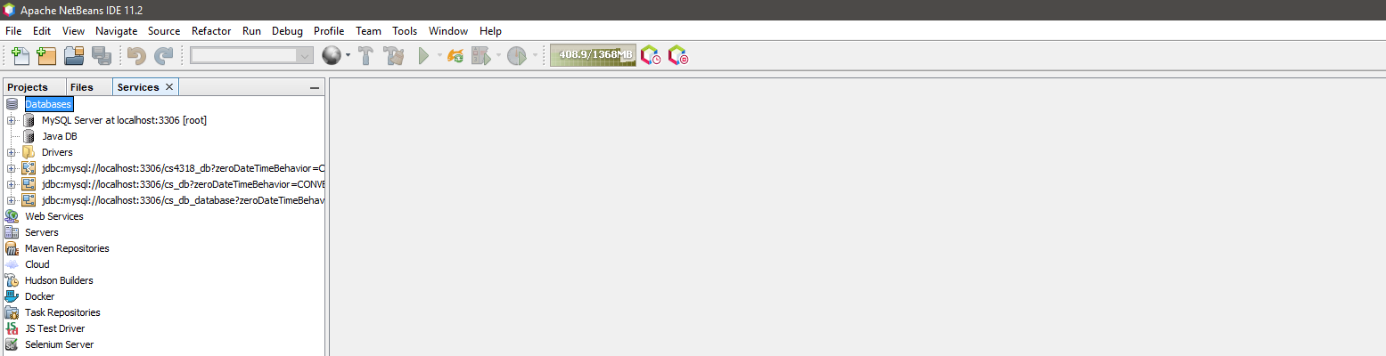

**Step 4**. Drag and drop file “cs_database.sql” into right blank space.

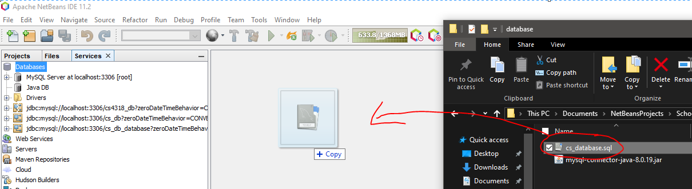

**Step 5**. Change database name to ‘cs_db’ if they are different, 2 of them. Then click on execute command button

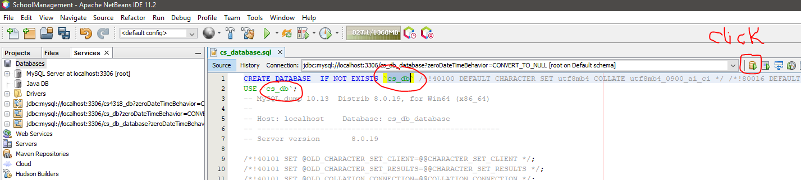

**Step 6**. New window popup, select “New Database Connection…”. Click OK.

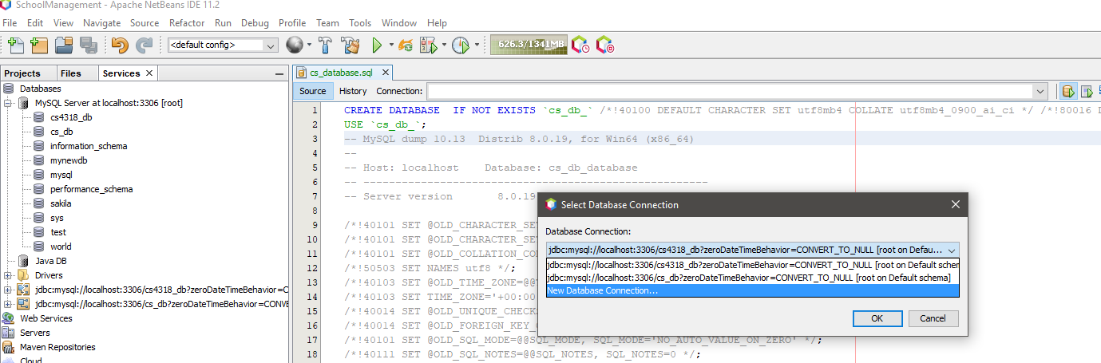

**Step 7.** Select “**MySQL (Connector/J driver)”** in the **Driver** box. Click **Add…** button and select file **“mysql-connector-java-8.0.19.jar”** in the same folder with database file. Click **Open** then click **Next**

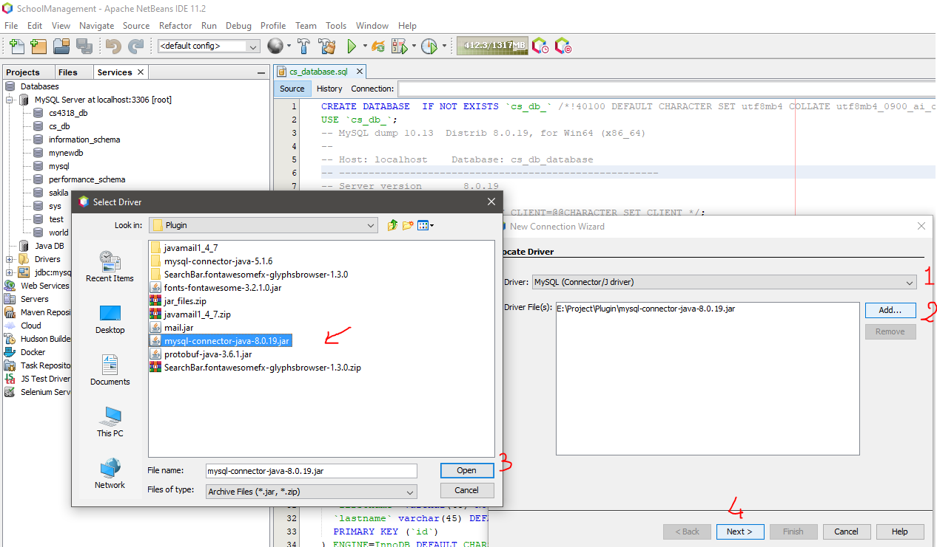

**Step 8.** Enter Username and Password of SQL server. Mine is both “root”, use yours. Then click Test Connection button, if you see Connection Succeeded then Username and Password are correct. If not you need to find your Username and Password of your SQL server. Then click Next

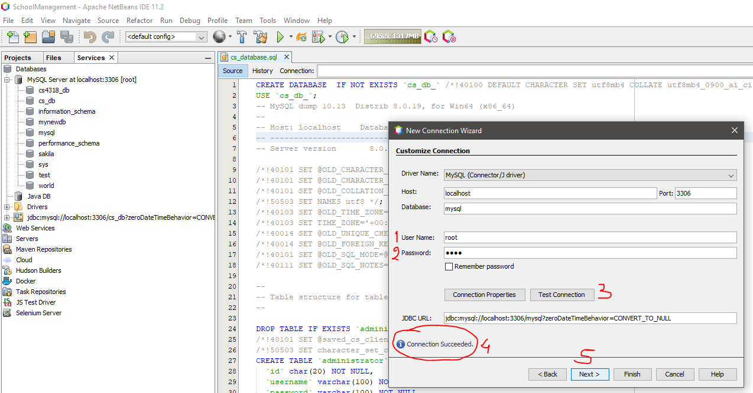

Step 9. Click next until you see the window below. Then change “mysql” to “cs_db” to match with database name to easy manage. Leave it default is ok. Then click **Finish.**

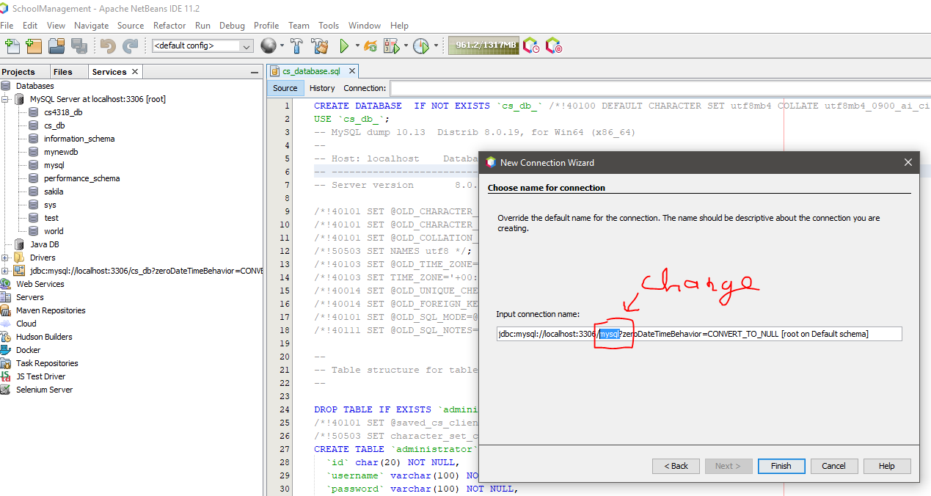

Step 10. Select connection with database name “jdbc:mysql://localhost:3306/cs_db?...” then click **OK**.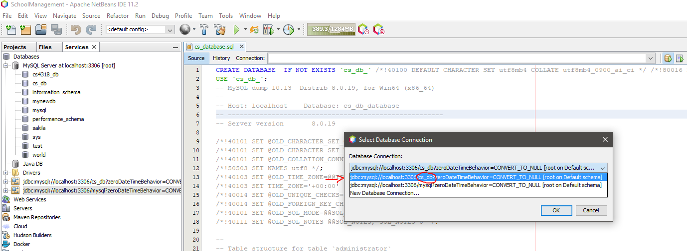

Step 11. Wait until the SQL Schema finish. Hope there is no error to import database. I tested on mine and there is no red error.

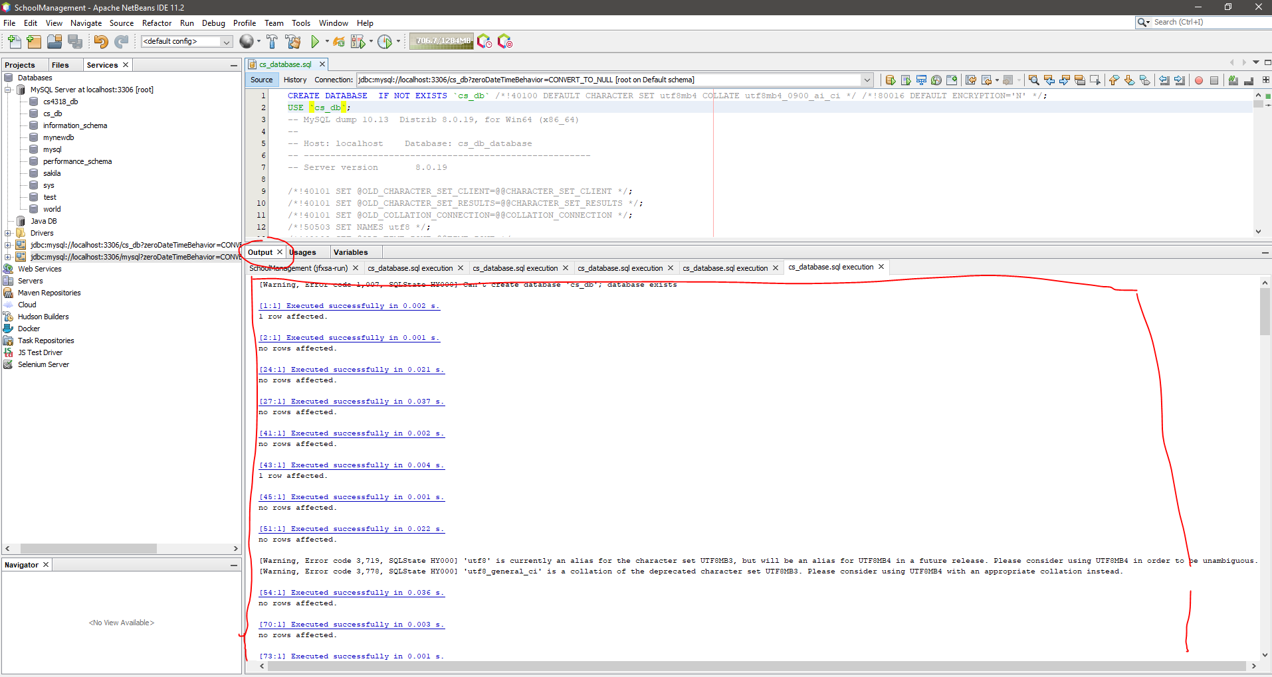

Step 12. Right click on “MySQL Server at locationhost:3306 [root]”, select Refresh. You will see new database name “cs_db” in the list.

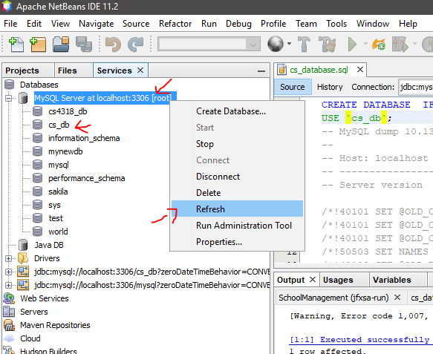

Step 13. Right Click on database “**cs_db**”, select “**Connect…**” if it is not automatically connected. Then connection “jdbc:mysql”//localhost:3306/**cs_db**?zero….” in the list below is connected. DONE. Now you can work on this database and run the project.

